### **Machine Learning Approach For Predictive Maintenance Aircraft Engine Using IBM Watson Studio**

Team Members

1. Ashish Santoshkumar Nair 19BCG10028
2. Satvik Shetty 19BAI10051
3. Sairam Pimple 19BCY10174
4. Ranjan Kudesia 19BCG10037

**Introduction**

**1.1 Overview**

The project uses a Machine Learning Approach for predictive Maintenance Aircraft Engine Using IBM Watson Studio.

For this project a combination of Python,Data Analysis, Exploratory Data Analysis, Data Preprocessing Techniques, Classification and Regression Algorithms

**1.2 Purpose**

This project can be used to predict aircraft engine failures before it happens.This can save a lot of lives, money and time.

Finding out the possibility of a system failure can be achieved with this project.

**2.Literature Survey**

**2.1 Existing Problem:**

An engine failure occurs when an engine unexpectedly stops producing power due to a malfunction other than fuel exhaustion. It often applies for aircraft, but other turbine engines can fail, like ground-based turbines used in power plants or combined diesel and gas vessels and vehicles.

Engine failure is highly risky and needs a lot of time for repair. Unexpected failure leads to loss of money and time. Predicting the failure prior, will save time, effort, money and sometimes even lives.

**2.2 Proposed Solution:**

The project aims to predict the failure of an engine by using Machine Learning to save loss of time & money thus improving productivity.

**3.Theoretical Analysis**

**3.1 Block Diagram**

The below diagram is the technical architecture of the whole project

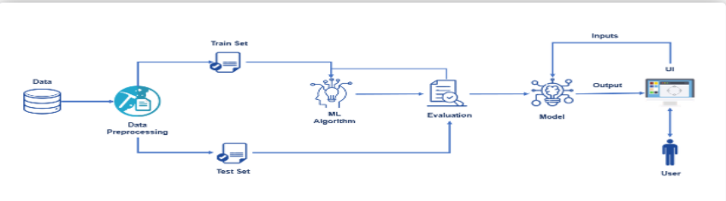

**3.2 Hardware/Software requirements:**

1. Jupyter Notebook

2. Spyder

3. Visual studios

4. IBM Cloud

a. IBM Watson studios

5. Flask

**6. Packages**:

a. Pandas

b. numpy

c. scikit -learn

d. matplotlib & seaborn

e. Pickle

**4.Experimental Investigations:**

1. Here, we are considering a dataset which has operational setting data and the data came from different sensors of an engine

2. The dataset contains 20631 data points inside the train dataset and we have 3 different datasets for train, test and truth.

3. We first built a model in a jupyter notebook.

4. The data is split into training and testing set in 8:2 ratio.

5. The model is trained using Logistic Regression .

6. Logistic Regression yields the most accurate result with around 99.93 percent accuracy .

7. Then we integrate the machine learning model with the flask to build the web application.

8. The model is then deployed using IBM Watson Studio.

**5.Flowchart:**

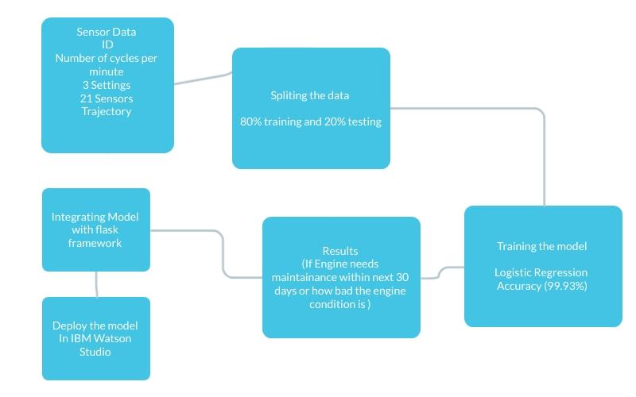

**6.Result:**

Once the proposed– model is implemented, you will be welcomed by a UI where the input received from 21 different engine sensors and 3 different settings can be either manually typed in and see if the engine needs a maintenance or not or we also have automatic system from which data from all the sensors can be collected which are available on our dataset and predict the condition of the engine and see if the engine needs a maintenance or not.

**7.Advantages:**

#### 1. Easily identifies trends and patterns

Machine Learning can review large volumes of data and discover specific trends and patterns that would not be apparent to humans. For instance, for an e-commerce website like Amazon, it serves to understand the browsing behaviors and purchase histories of its users to help cater to the right products, deals, and reminders relevant to them. It uses the results to reveal relevant advertisements to them.

#### 2. No human intervention needed (automation)

With ML, you don’t need to babysit your project every step of the way. Since it means giving machines the ability to learn, it lets them make predictions and also improve the algorithms on their own. A common example of this is anti-virus softwares; they learn to filter new threats as they are recognized. ML is also good at recognizing spam.

#### 3. Continuous Improvement

As ML Algorithms gain experience, they keep improving in accuracy and efficiency. This lets them make better decisions. Say you need to make a weather forecast model. As the amount of data you have keeps growing, your algorithms learn to make more accurate predictions faster.

#### 4. Handling multidimensional and multi-variety data

Machine Learning algorithms are good at handling data that are multidimensional and multi-variety, and they can do this in dynamic or uncertain environments.

**Disadvantages:**

#### 1. Data Acquisition

Machine Learning requires massive data sets to train on, and these should be inclusive/unbiased, and of good quality. There can also be times where they must wait for new data to be generated.

#### 2. Time and Resources

ML needs enough time to let the algorithms learn and develop enough to fulfill their purpose with a considerable amount of accuracy and relevancy. It also needs massive resources to function. This can mean additional requirements of computer power for you.

#### 3. Interpretation of Results

Another major challenge is the ability to accurately interpret results generated by the algorithms. You must also carefully choose the algorithms for your purpose.

#### 4. High error-susceptibility

Machine learning is autonomous but highly susceptible to errors. Suppose you train an algorithm with data sets small enough to not be inclusive. You end up with biased predictions coming from a biased training set. This leads to irrelevant advertisements being displayed to customers. In the case of ML, such blunders can set off a chain of errors that can go undetected for long periods of time. And when they do get noticed, it takes quite some time to recognize the source of the issue, and even longer to correct it.

**8.Applications:**

This solution can be applied anywhere there is a use of an aircraft engine.

Commercial planes,passenger planes or even fighter planes-this prediction system can be used.Its application depends on the fact that the machine uses an aircraft engine.

**9.Conclusion:**

Engine failure is highly risky and needs a lot of time for repair. Unexpected failure leads to loss of money and time. Predicting the failure prior, will save time, effort, money and sometimes even lives. The failure can be detected by installing the sensors and keeping a track of the values. The failure detection and predictive maintenance can be for any device, out of which we will be dealing with the engine failure for a threshold number of days.

The project aims to predict the failure of an engine by using Machine Learning to save loss of time & money thus improving productivity

This solution helps save so much time and money by simply just entering the values we get from the different sensors which are already in place for a commercial plane and this data simply putting in our website can give you a 99.93 percent accuracy about the condition of your aircraft engine. Whether the engine is in good condition or not or if it needs a maintenance in the next 30 days to get the engine back in good condition and this can help save lives of countless people by preventing any engine malfunction midflight.

**10.Future Scope:**

Currently our model is using sensor data received from airplanes engine and training the model using these datasets to predict if the engine is in good condition or not. We have to manually enter all the sensor data received from all these sensors in our website for manual prediction. Although this is very accurate and trustworthy , in future we can even make it better by configuring all the different sensors in such a way that all the data is directly sent to our website and we can monitor the engine constantly at particular intervals of time and we will immediately come to know if some problem is there with the engine and get it fixed as soon as possible. .

**11.Bibiliography:**

**1.**[**https://data-flair.training/blogs/advantages-and-disadvantages-of-machine-learning/**](https://data-flair.training/blogs/advantages-and-disadvantages-of-machine-learning/)

[**https://analyticsindiamag.com/machine-learning-for-predictive-maintenance-key-approaches-techniques-to-consider/**](https://analyticsindiamag.com/machine-learning-for-predictive-maintenance-key-approaches-techniques-to-consider/)

[**https://ieeexplore.ieee.org/document/9289466**](https://ieeexplore.ieee.org/document/9289466)

[**https://aerospace.honeywell.com/us/en/learn/about-us/blogs/moving-beyond-the-hype-of-predictive-maintenance**](https://aerospace.honeywell.com/us/en/learn/about-us/blogs/moving-beyond-the-hype-of-predictive-maintenance)

[**https://www.infoq.com/articles/machine-learning-techniques-predictive-maintenance/**](https://www.infoq.com/articles/machine-learning-techniques-predictive-maintenance/)

**Appendix**

1. **Source Code**

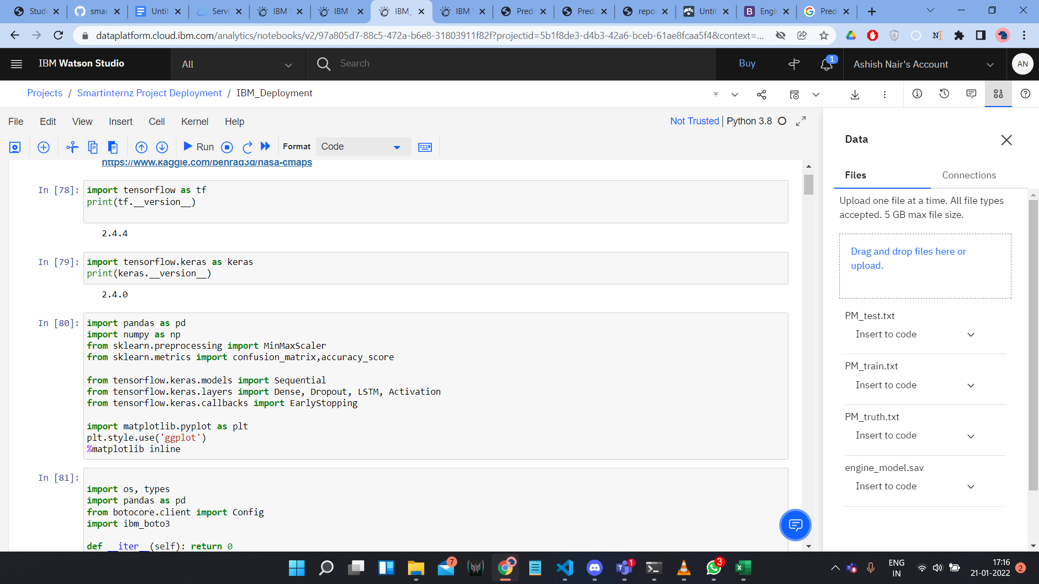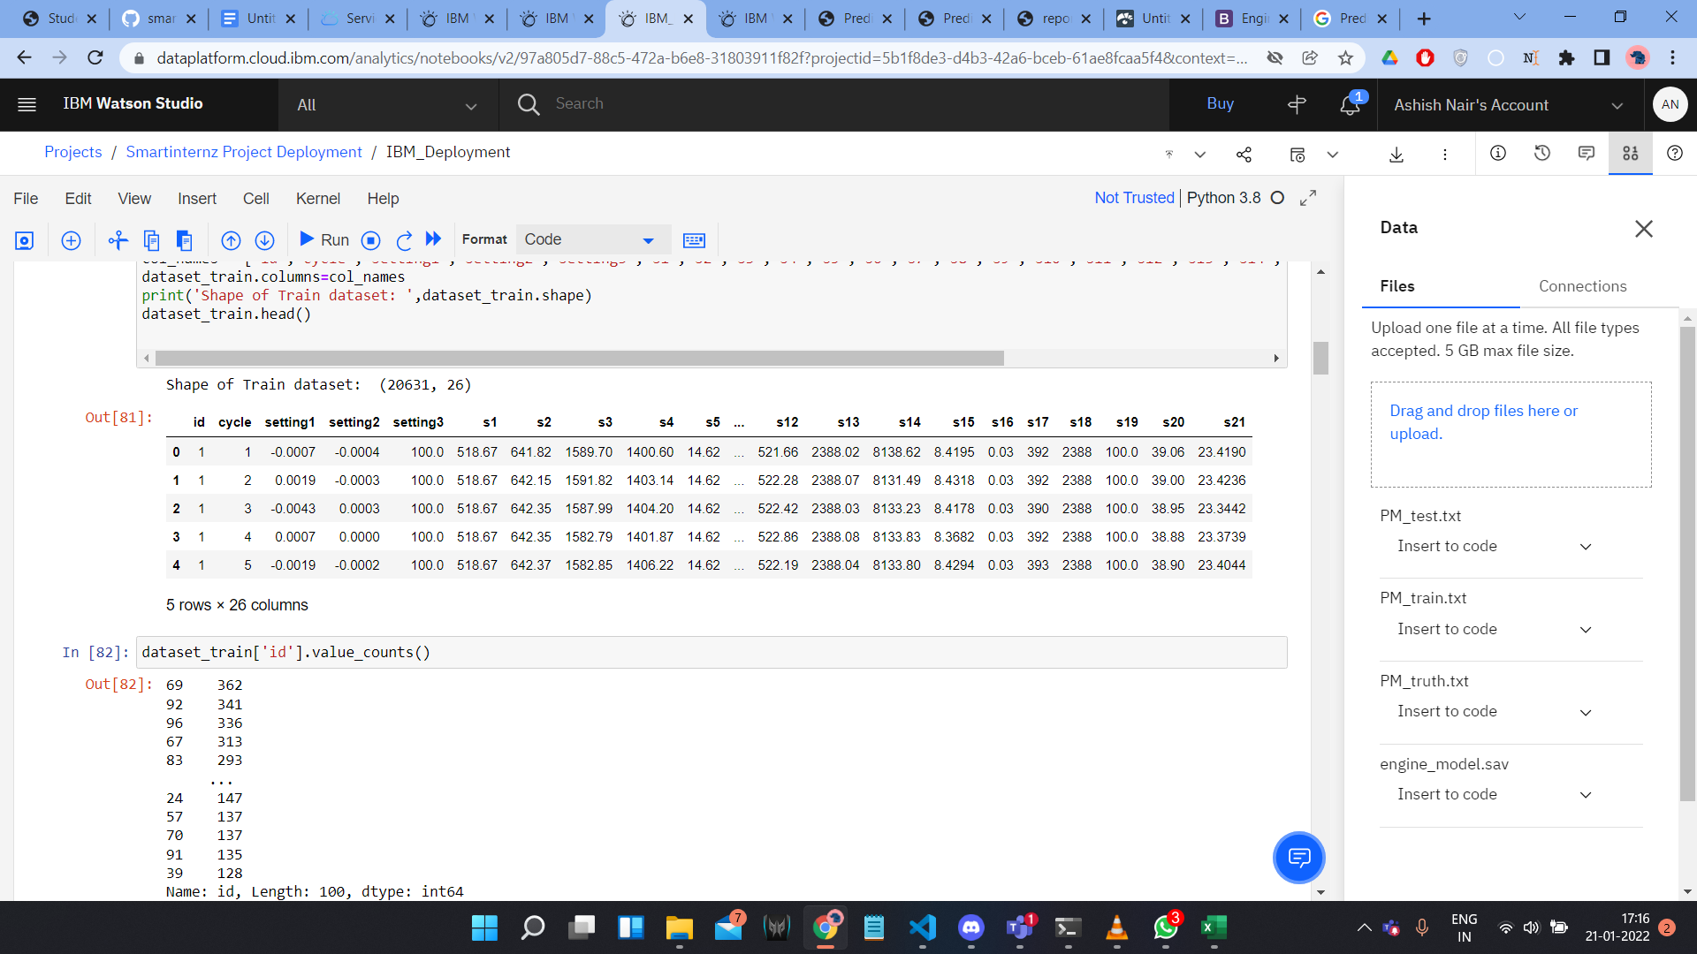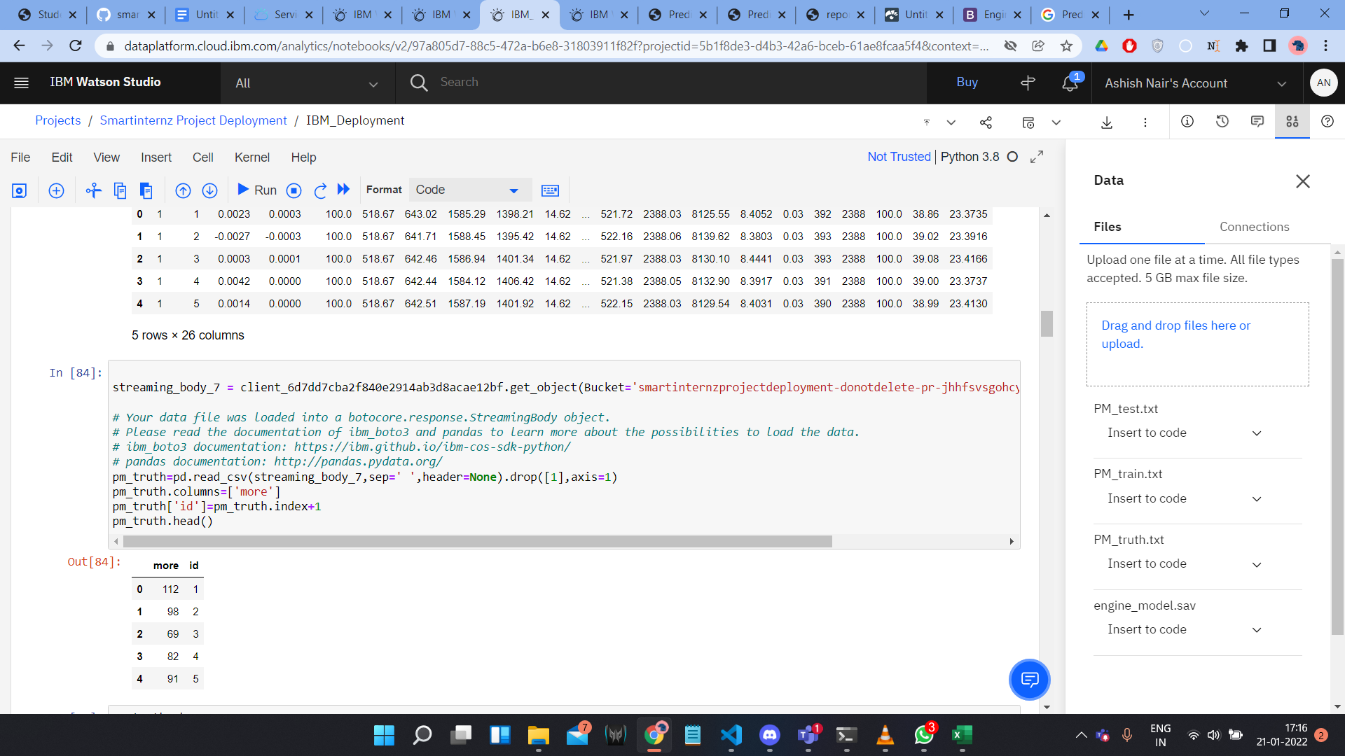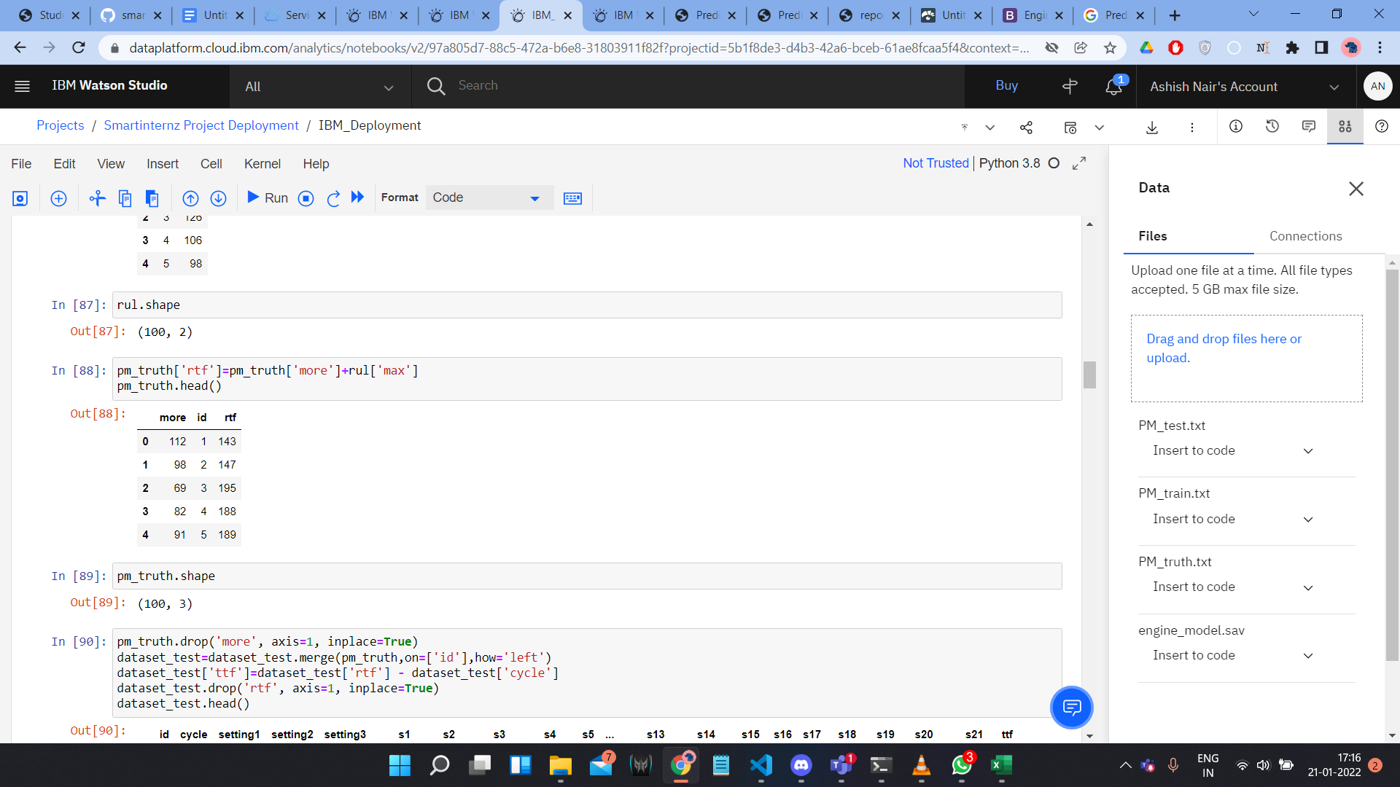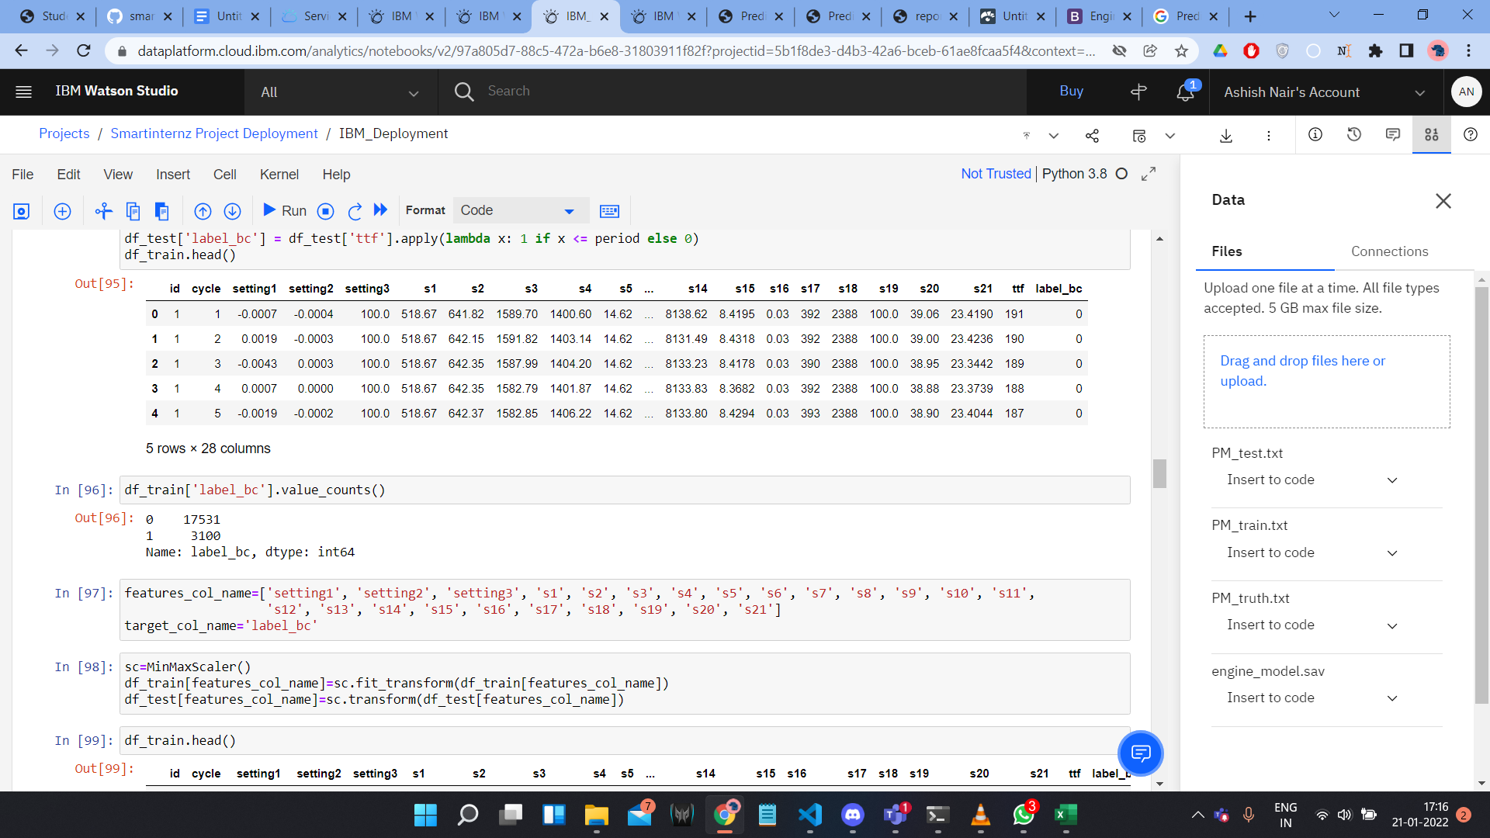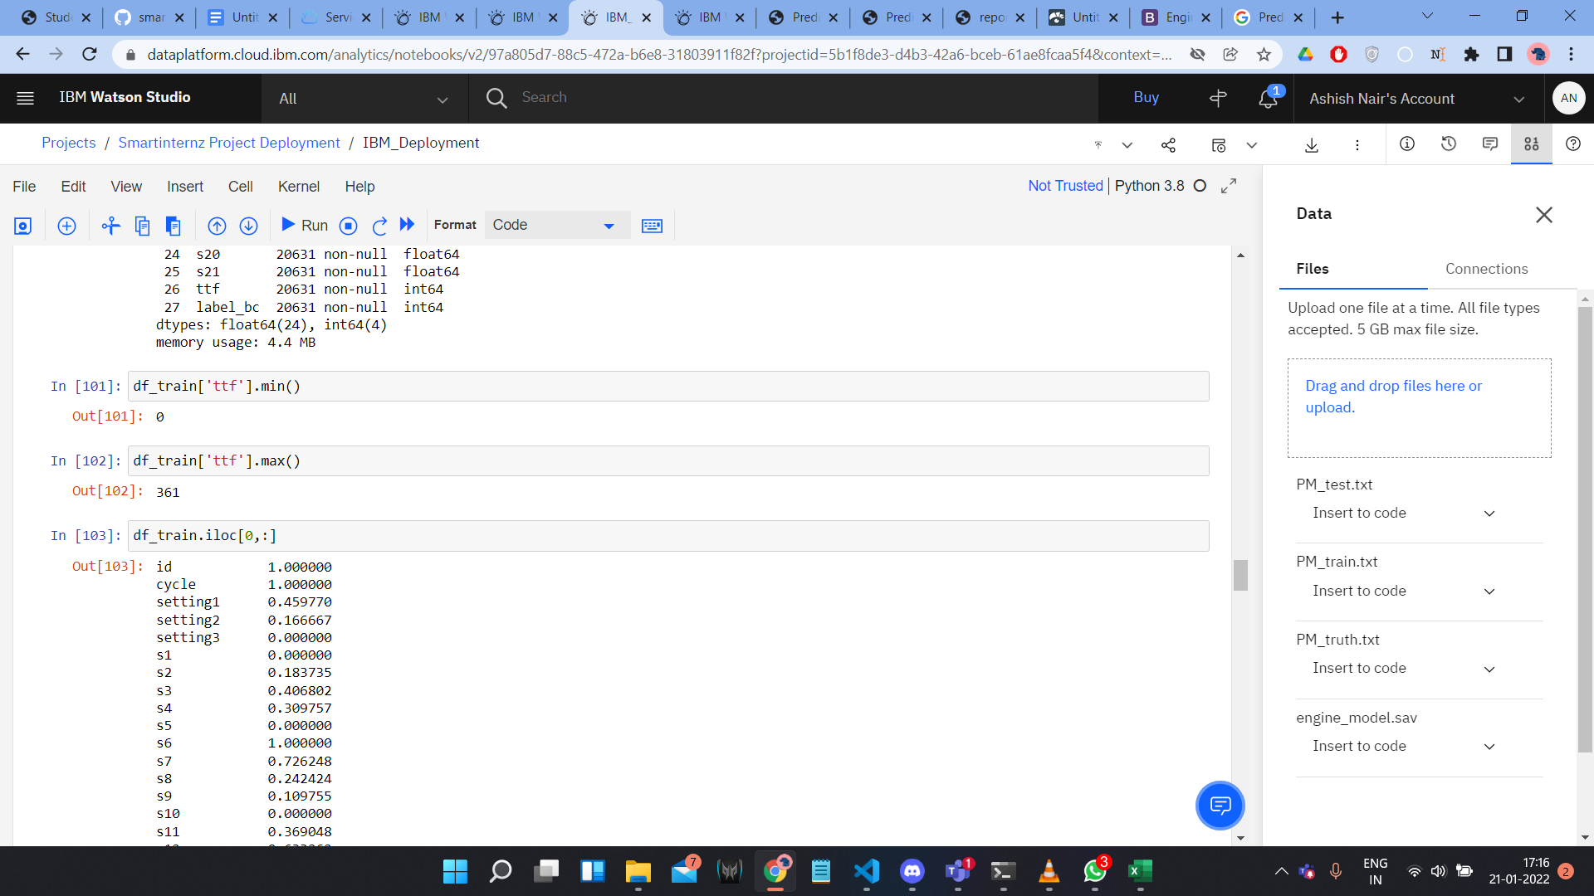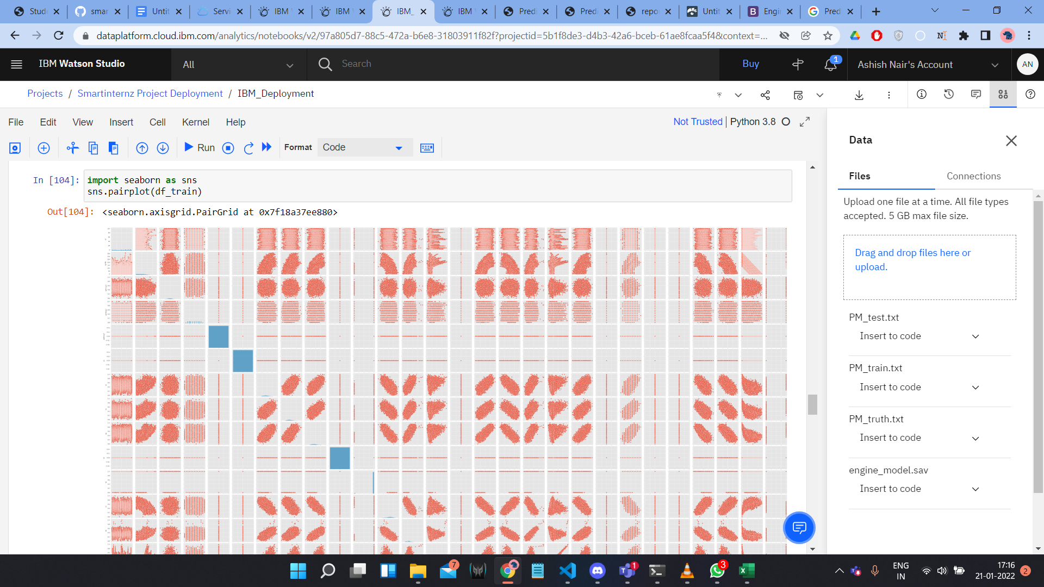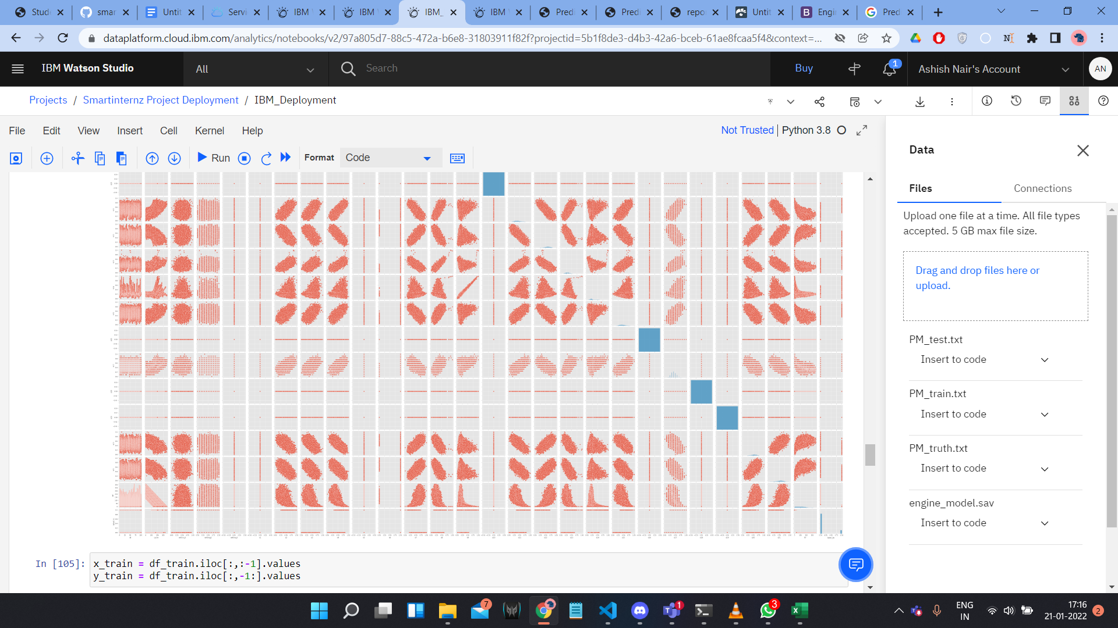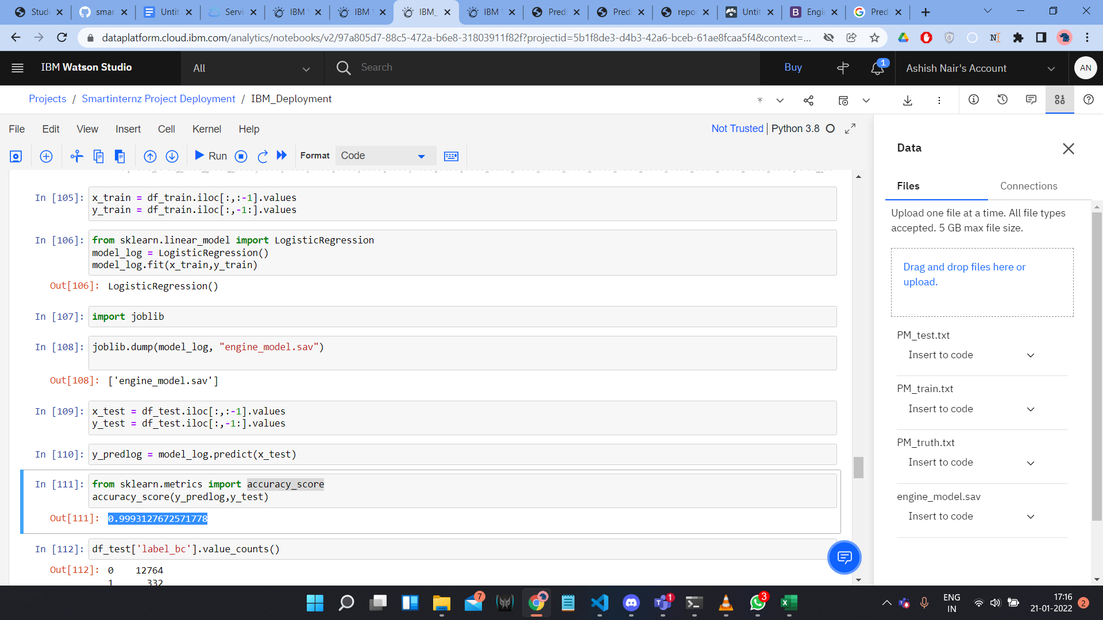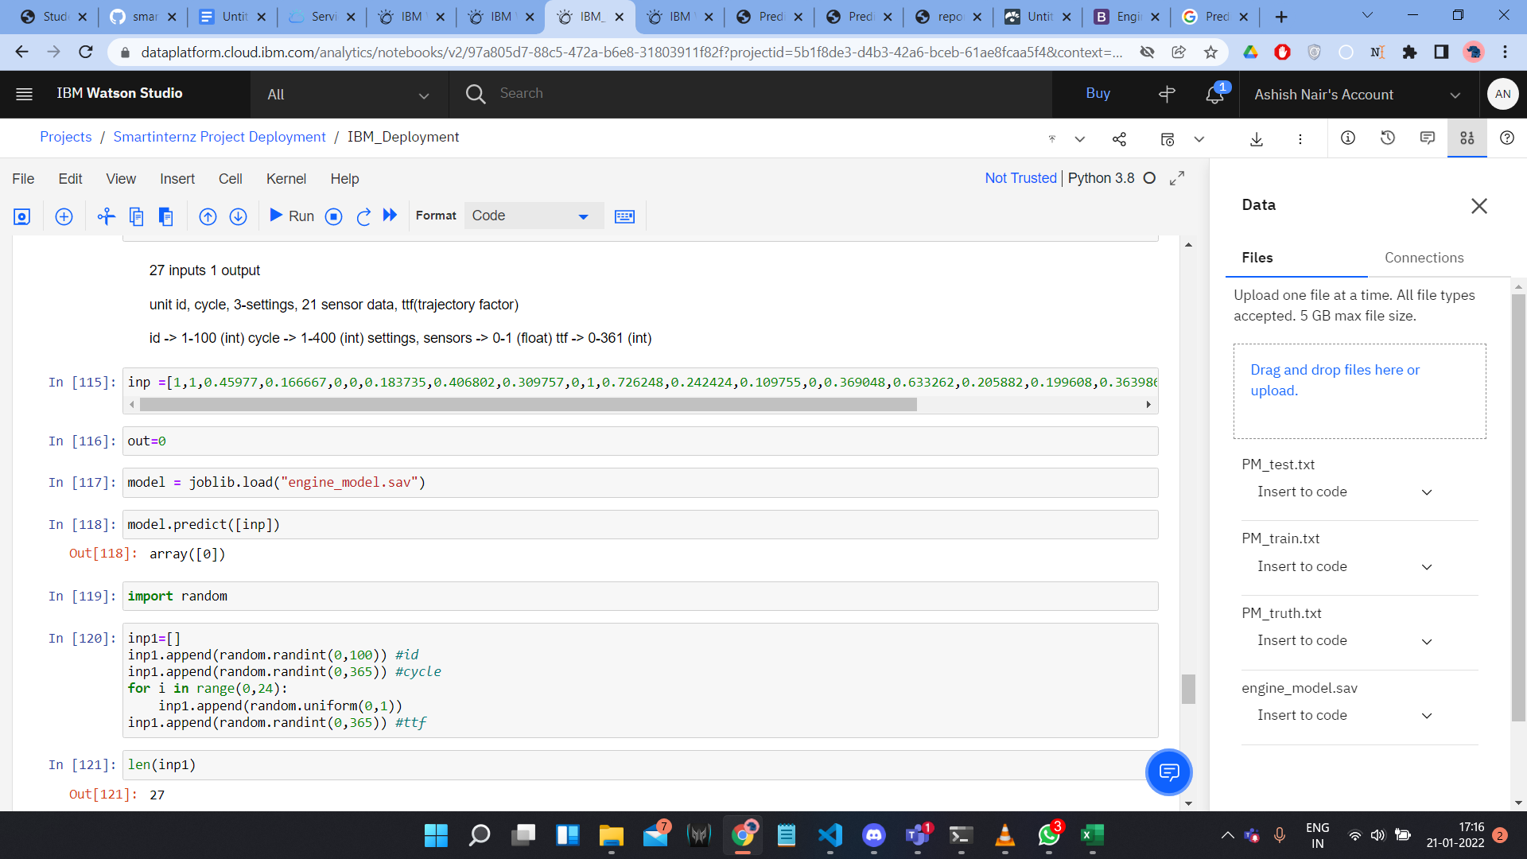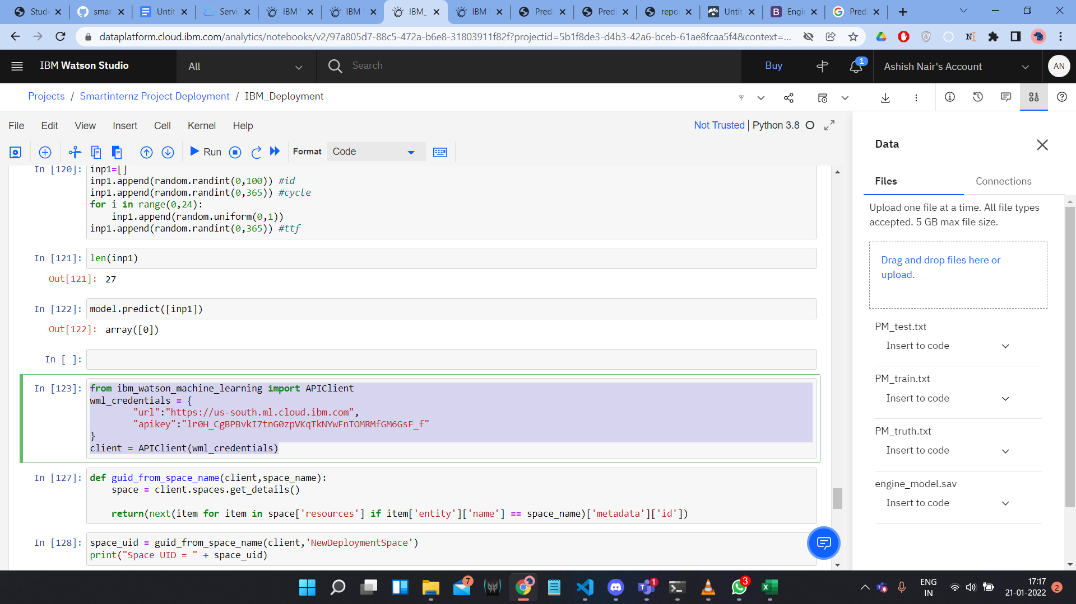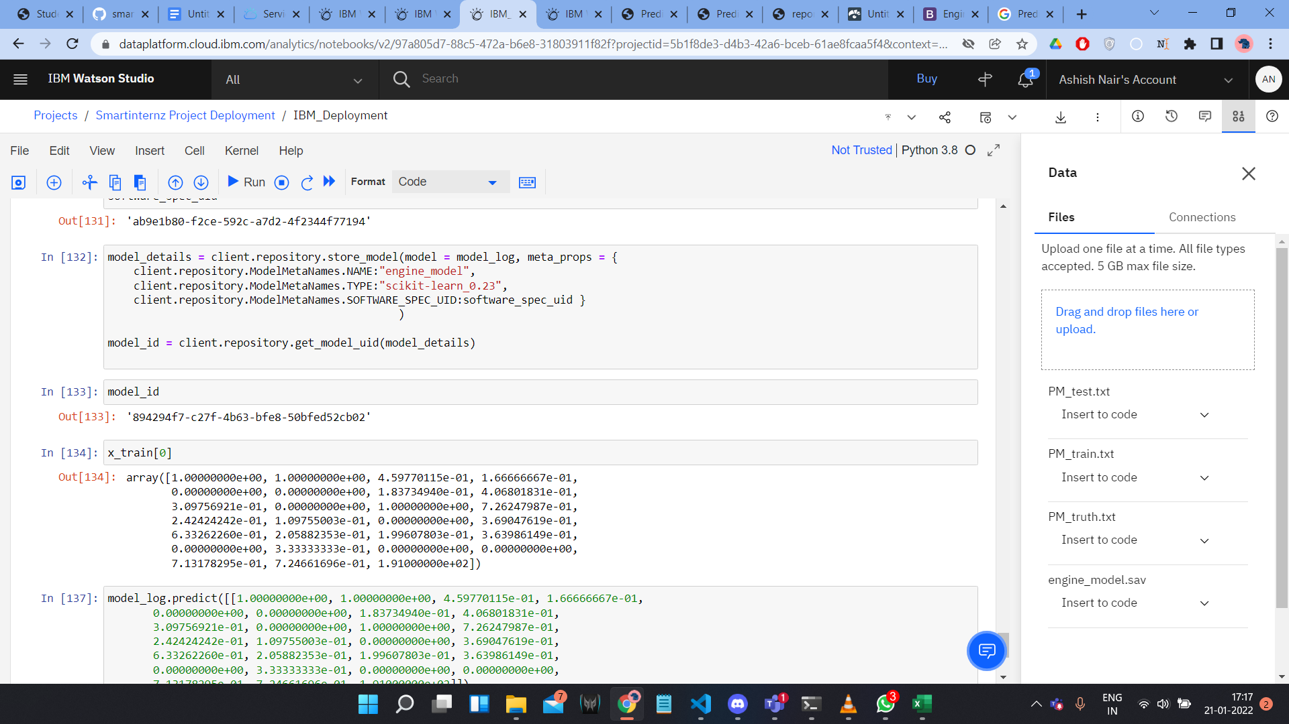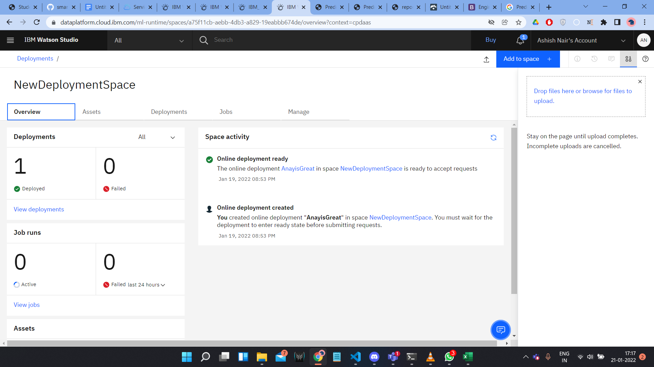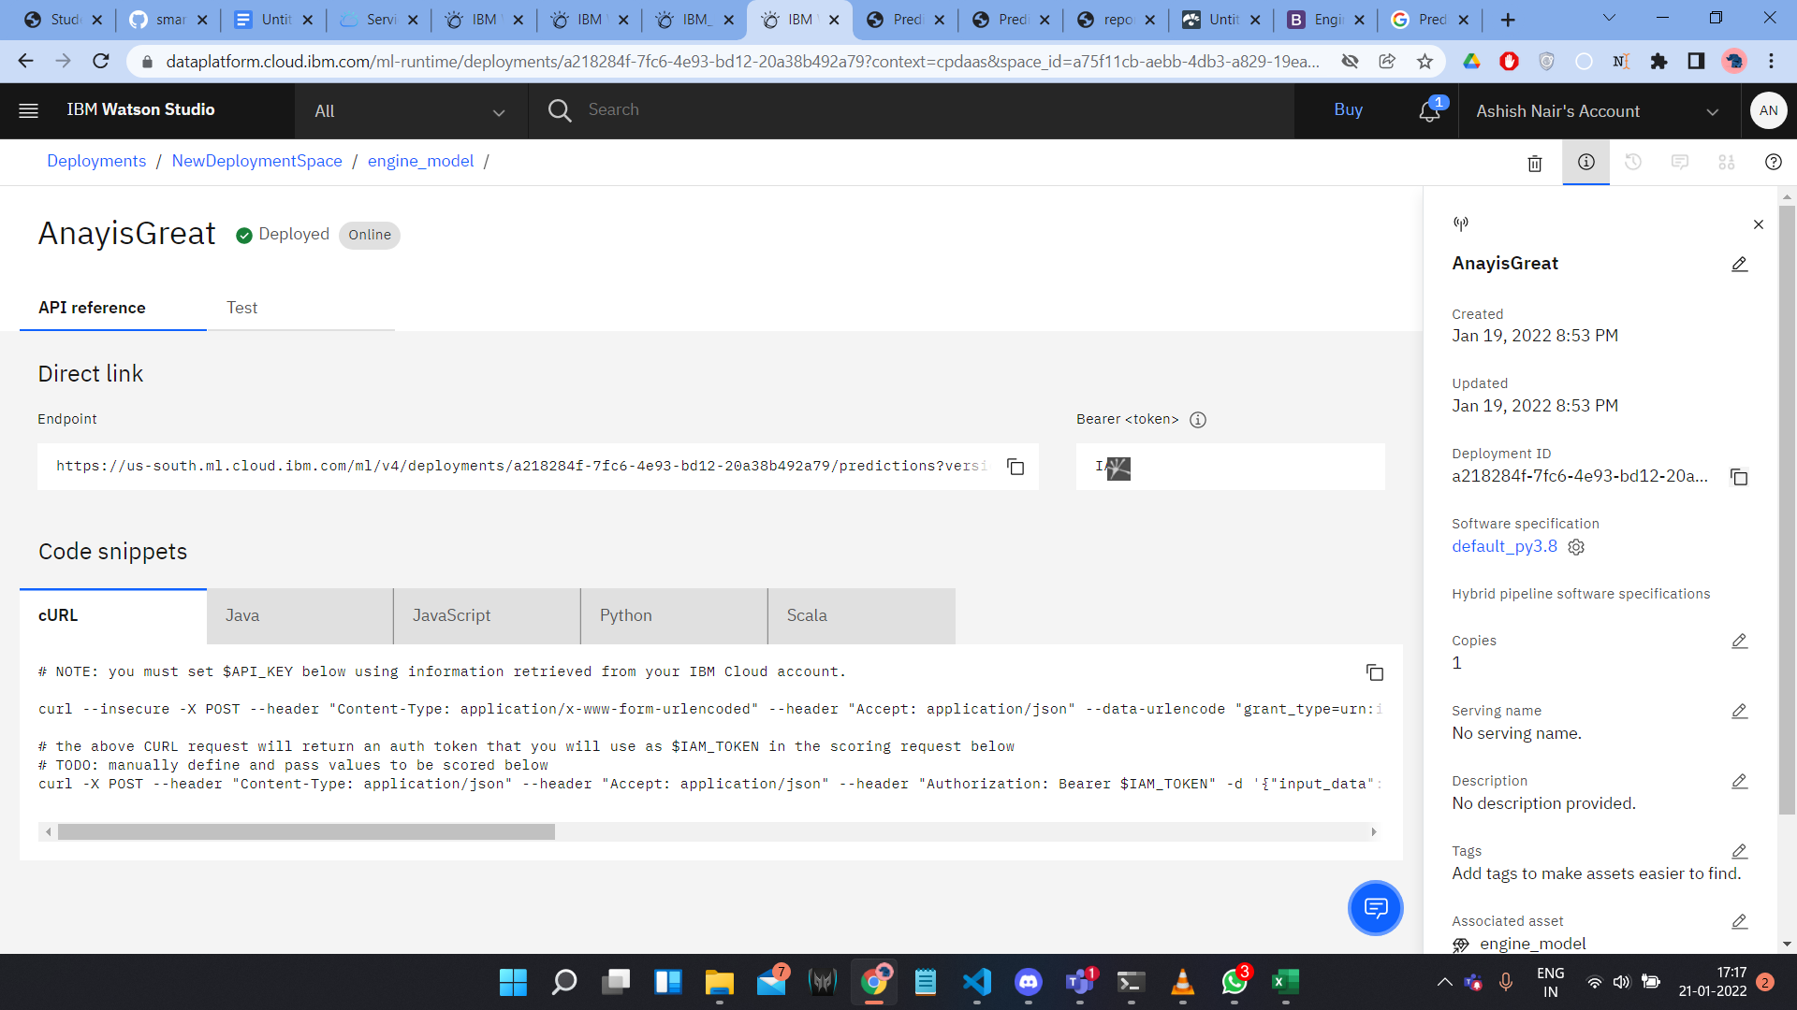

**Flask python file**

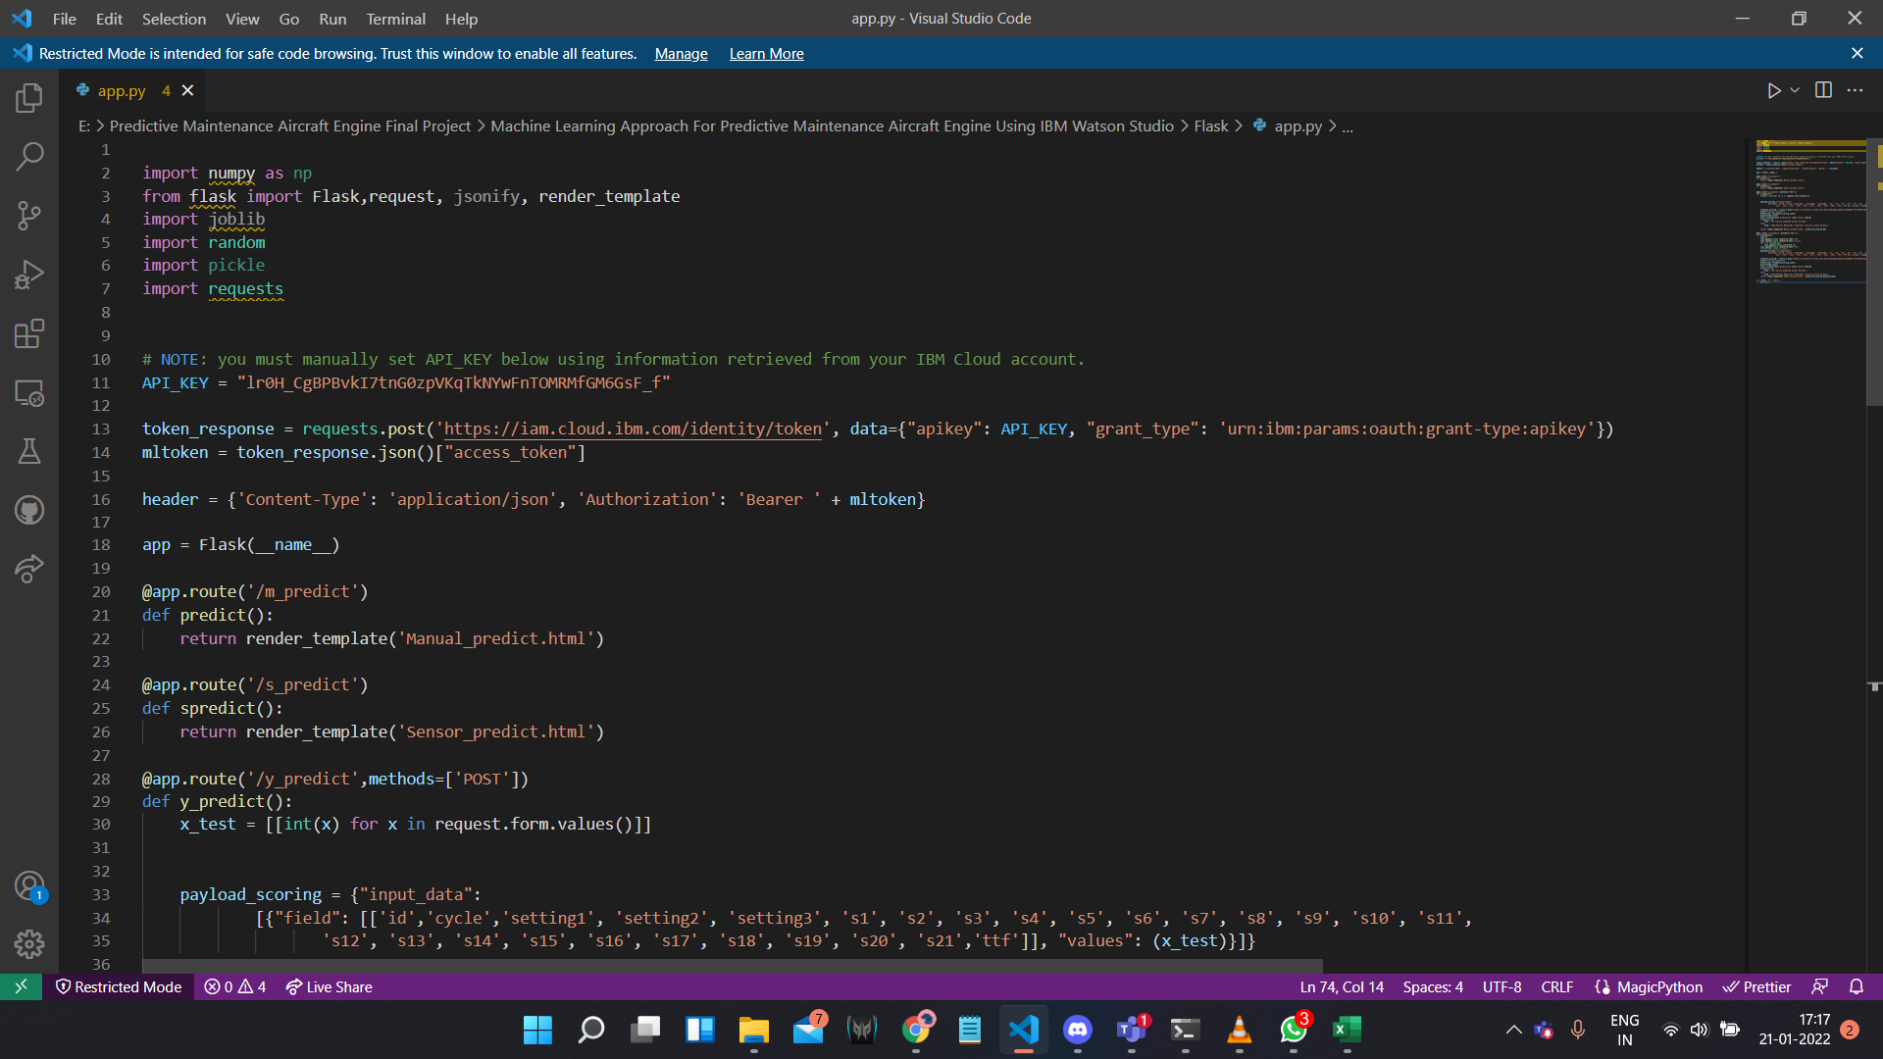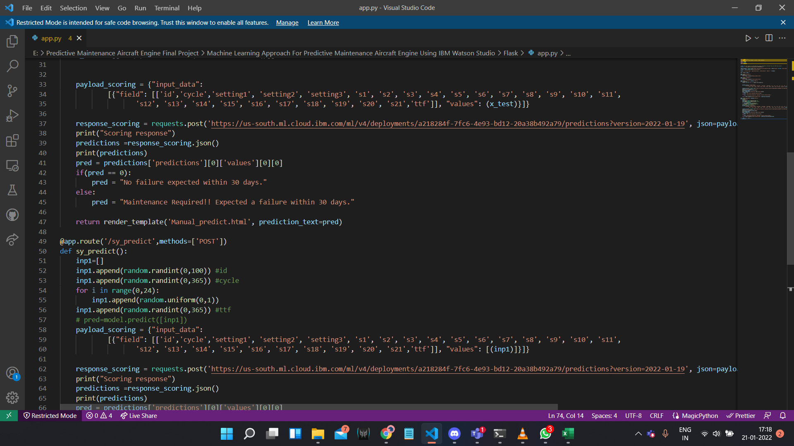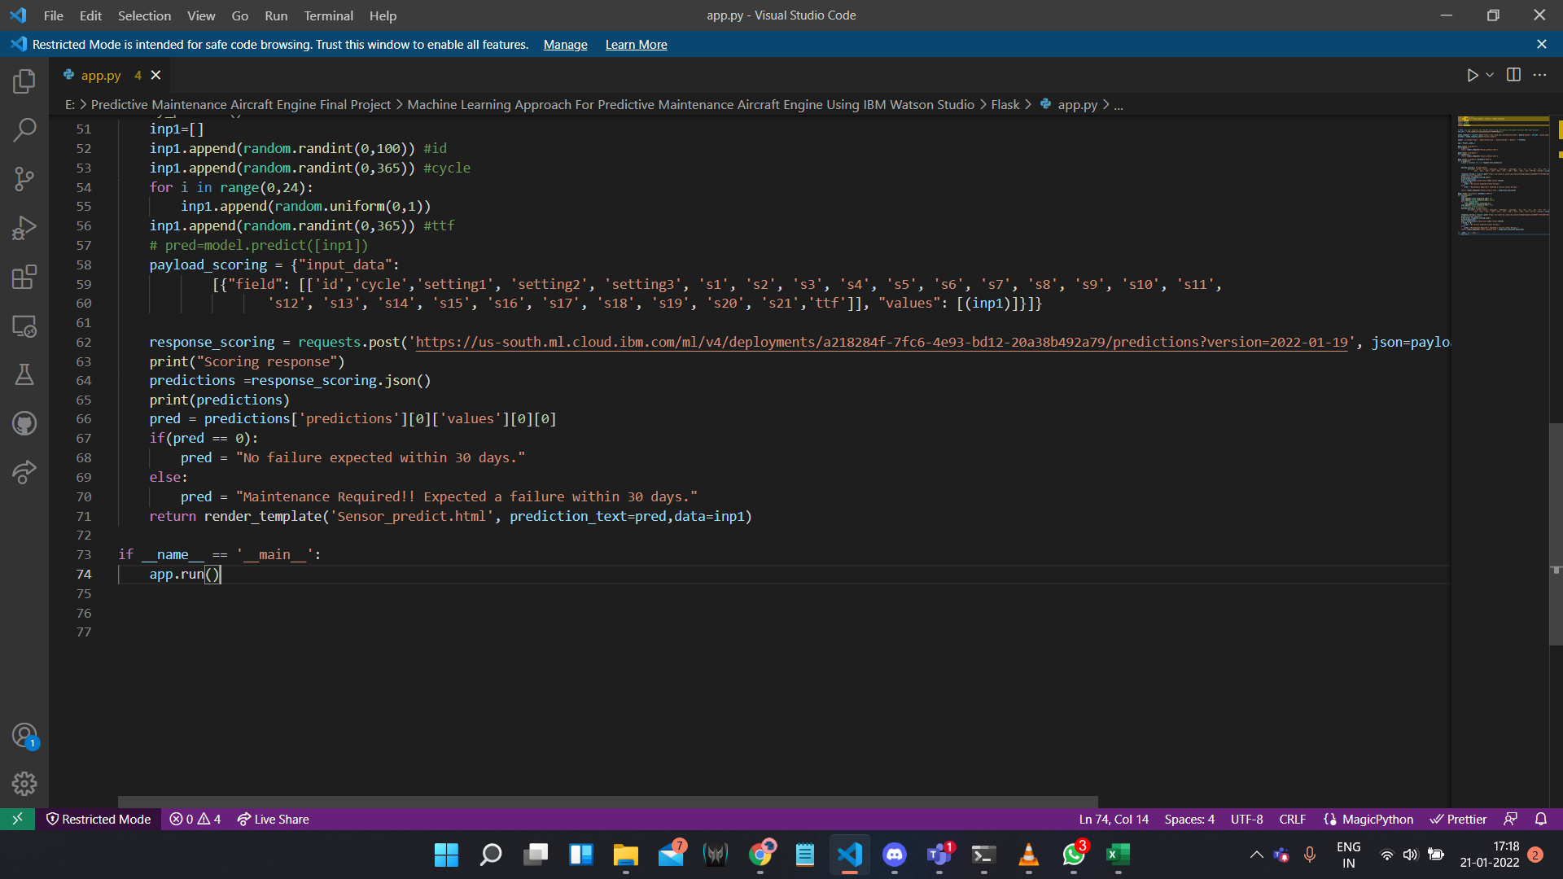

**Output Page:**

